Kanban Task Management System
The Kanban Task Management System is a user-friendly Java-based application designed to enhance efficiency in task management. With features like user registration, task tracking, and reporting, this tool simplifies organizing work using the Kanban method.
Key Features
- **User Registration and Authentication**:
- Allows secure creation of accounts with credential validation.
- Login functionality ensures only registered users access their dashboards.
- **Task Handling**:
- Facilitates task creation, modification, and management.
- Assign developers to tasks for better tracking.
- Auto-generated task IDs for unique identification.
- **Reports**:
- Displays detailed task data filtered by status or assigned team members.
- Helps evaluate progress effectively.
- **Simple Menu Navigation**:
- A text-based menu simplifies interaction with all features.
- **Robust Validation**:
- Prevents invalid inputs and maintains consistent functionality.
Installation Steps
To set up the application, follow these steps:
1. Download the repository by running the following command:
```bash
git clone https://github.com/lulama-baloyi/Kanban-Task-Manager.git
cd Kanban-Task-Manager
```
2. Build the project with Maven:
```bash
mvn clean install
```
3. Launch the application:
```bash
java -jar target/kanban-task-manager.jar
```
How to Use the Application
1. **Start the Application**:
Open the application in your terminal or development environment.
2. **Register a User**:
- Enter a valid username and password to create an account.
- Ensure the username has an underscore and meets length requirements.
- Passwords should include uppercase, lowercase, digits, and special characters.
3. **Login**:
- Provide your registered credentials.
- If incorrect, the system will prompt you to re-enter details.
4. **Manage Tasks**:
- Add tasks by providing a name, description, developer, and duration.
- Use the task ID for easy reference or updates.
5. **Generate Reports**:
- View task details, sorted by developers or task status.
6. **Exit the Program**:
- Select the 'Quit' option from the main menu.

Visual Demonstrations
Start the Application:
- The application begins with a main menu providing the following options:
  - 1. Sign Up
  - 2. Login
  - 3. Exit
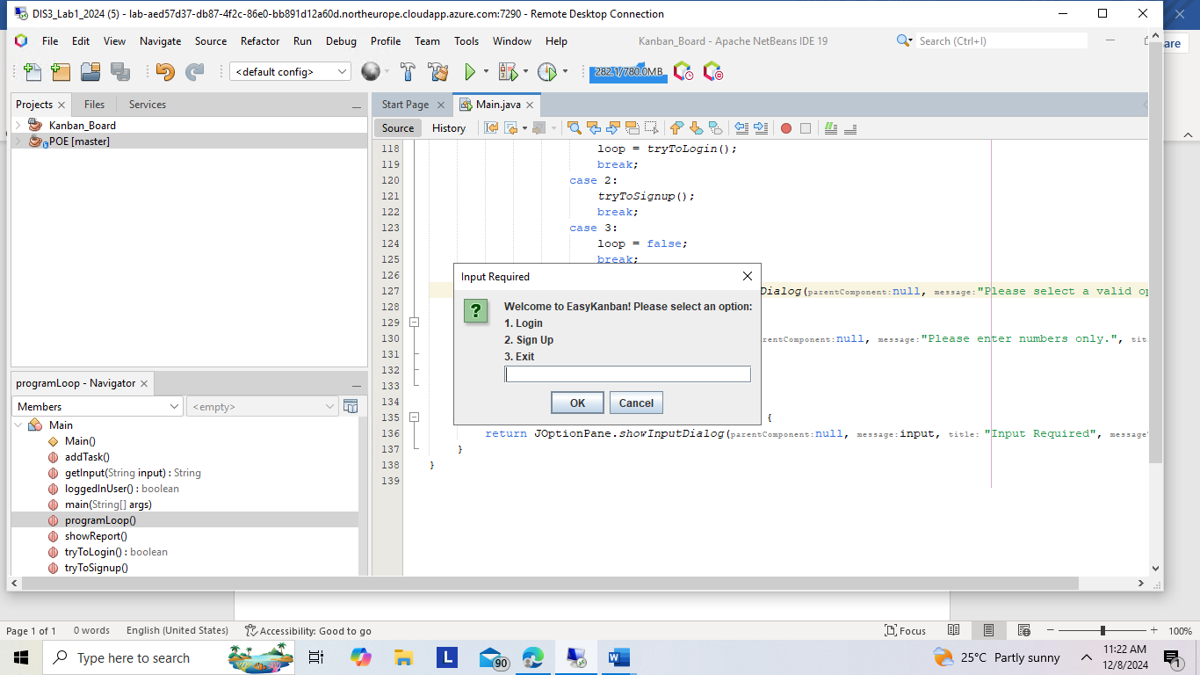
- Sign Up:
- This option allows new users to create an account.
- Users must enter:
  - A valid username that contains an underscore (_) and is at least 5 characters long.
  - A strong password that includes:
    - At least one uppercase letter.
    - At least one lowercase letter.
    - At least one digit.
    - At least one special character.
- If any validation fails, the system prompts the user to re-enter the details.
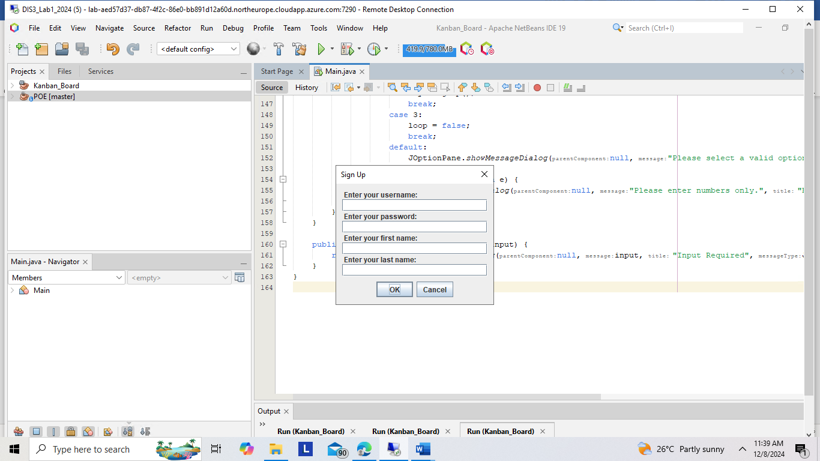

Successful Sign-In
- When a user provides valid credentials (username and password), the system allows access to the main menu and displays a success message.
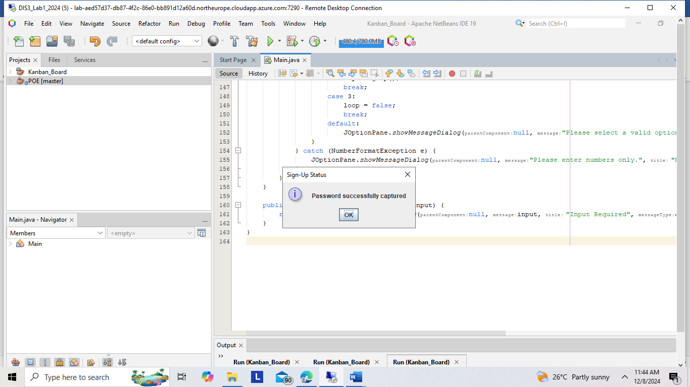

Unsuccessful Sign-In
- If the user provides incorrect credentials (e.g., an invalid username or password), the system denies access and prompts the user to try again.
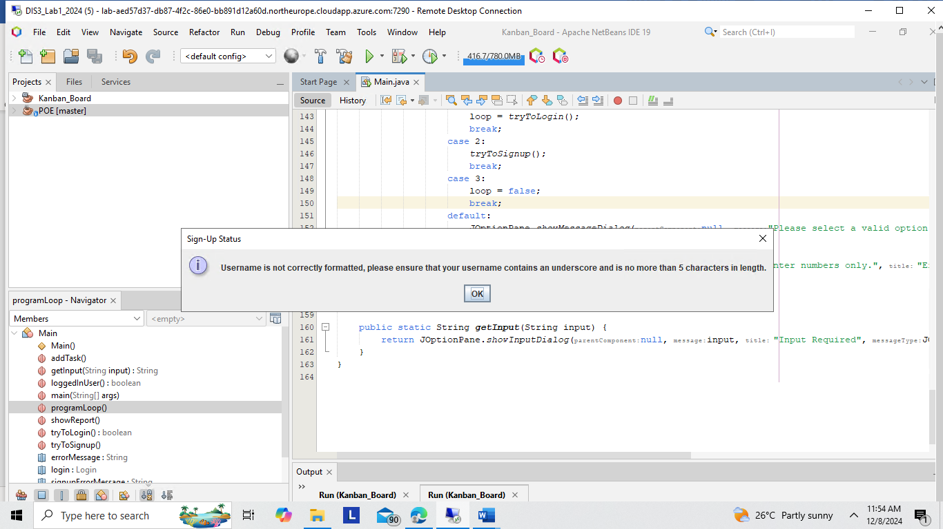
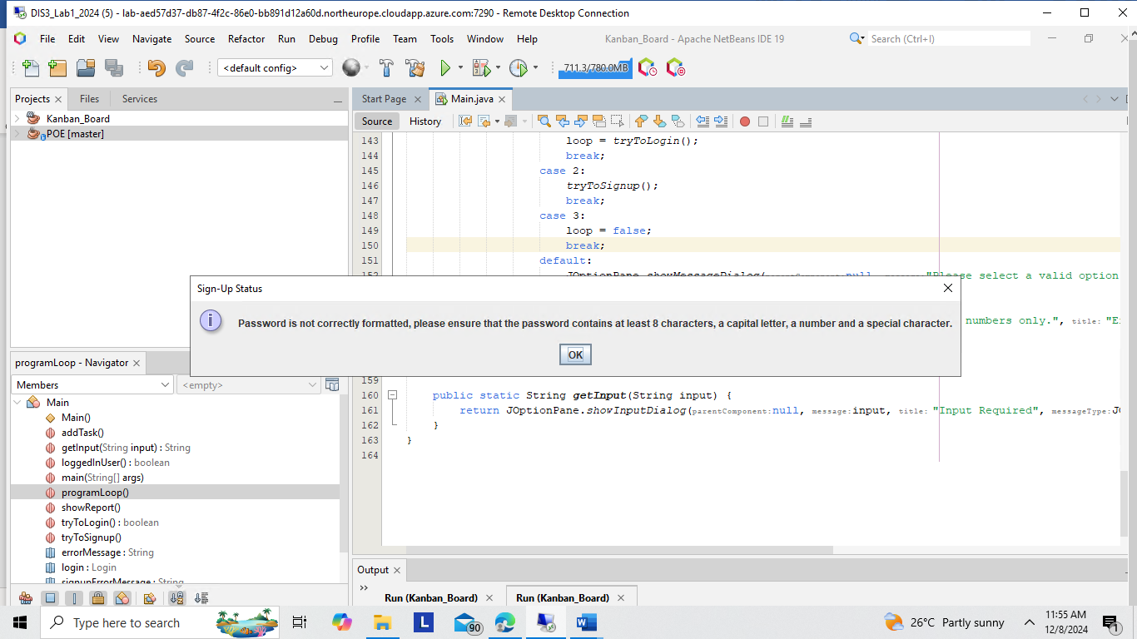
- Login:
- This option enables registered users to access their account.
- Users must enter:
  - Their username.
  - Their password.
- If the credentials are incorrect, the system will display an error message and allow retries.
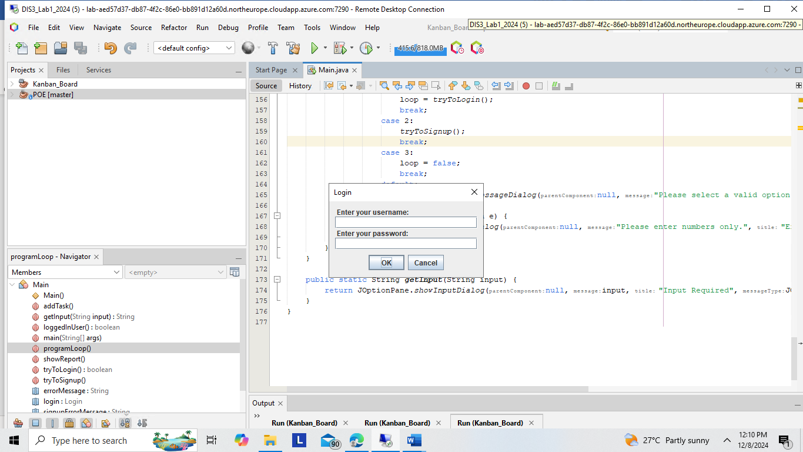

Successful Login:
This screenshot depicts a successful login attempt. The user is welcomed to the main menu after providing valid credentials.
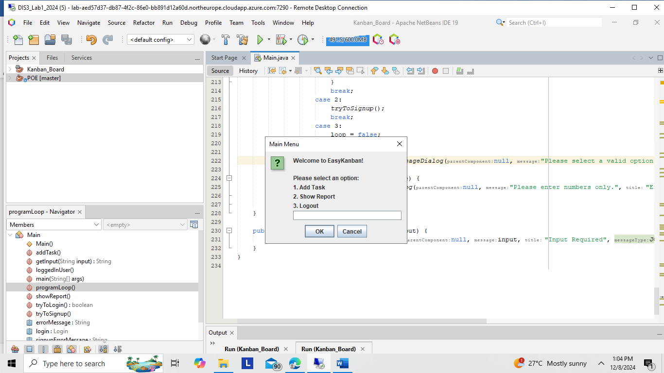

- Add Tasks:
- After logging in, users can select the Add Task option.
- The system will prompt for:
  - Task Name: A short, descriptive name for the task.
  - Task Description: A concise description (must be less than or equal to 50 characters).
  - Developer Details: The first and last name of the developer assigned to the task.
  - Task Duration: The estimated time to complete the task in hours.
- Each task is assigned a unique Task ID generated automatically by the system.
- The system validates all inputs and displays a success message upon successful task creation.
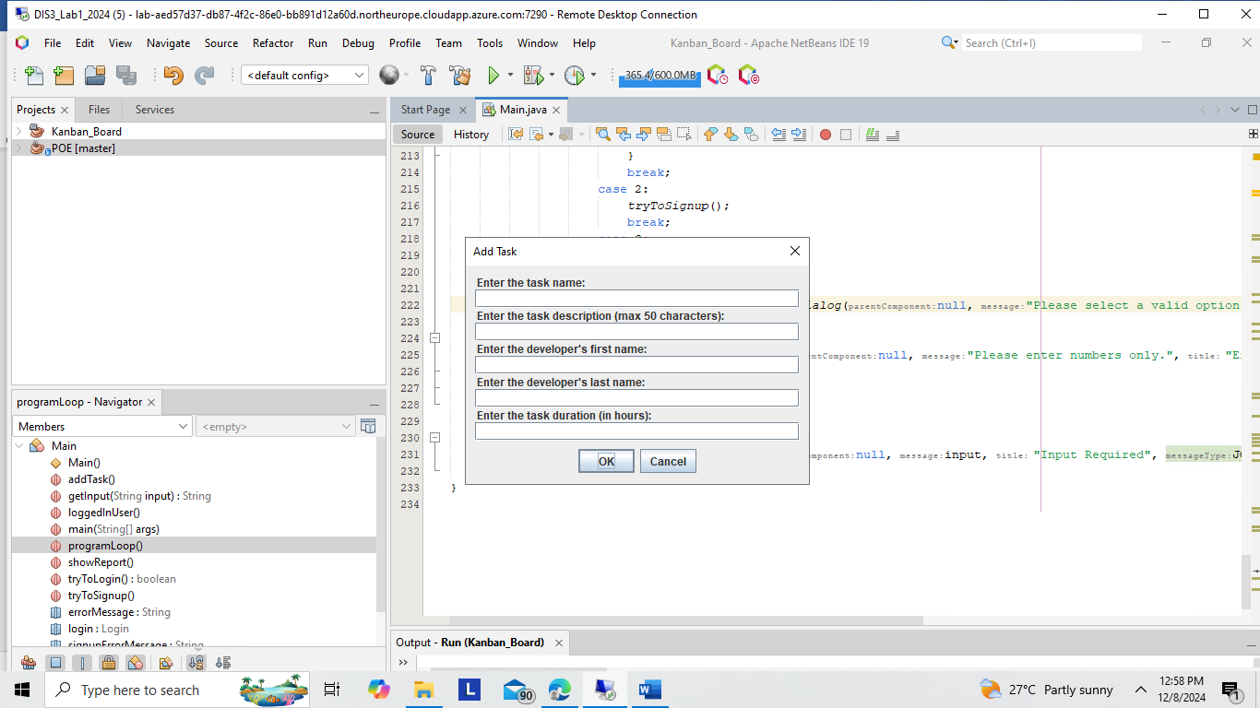
- Show Reports:
  - Users can view a summary of all tasks they have created.
  - Reports are grouped by task status (e.g., "To Do," "In Progress," "Completed").
  - The system also allows filtering tasks by developer name.
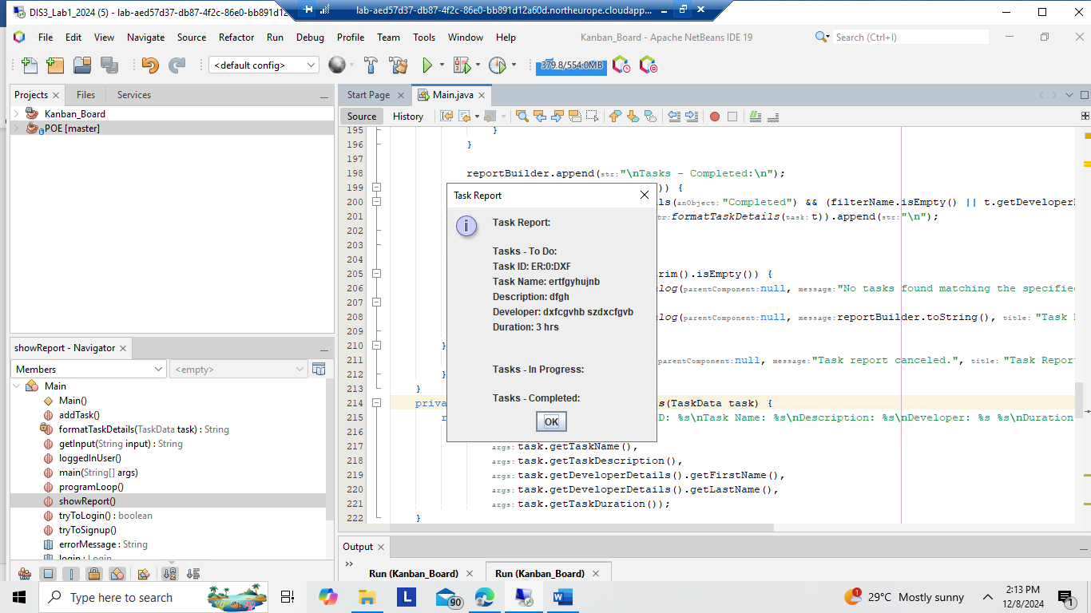
- Exit the Program:
- Users can exit the application by selecting the Quit option.
- The system ensures all processes are finalized before closing.
